HANDS Workshop

HANDS Lecture: Project start-ups Innovation and Entrepreneurship

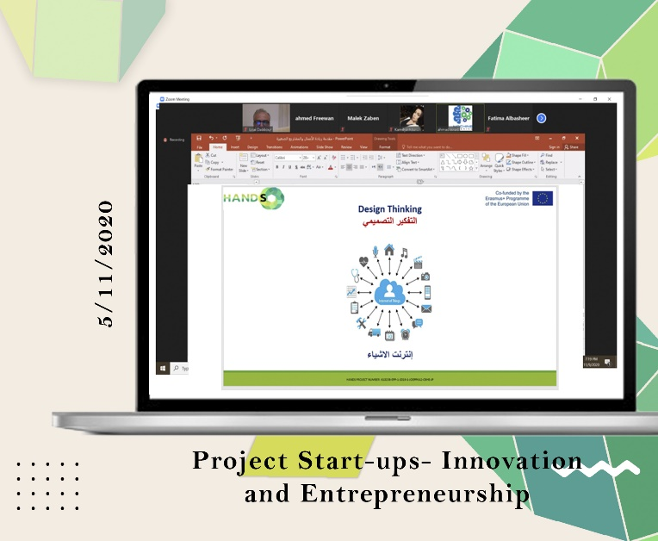
WP 6: DEVELOPMENT
Date: Thursday, 5/11/2020
Organizer: Jordan University of Science and Technology (JUST)
Location: Online via ZOOM platform
Dr. Abdullah Daradkeh of JUST lectured on project start-ups, emphasizing innovation and entrepreneurship's technical aspects. Leveraging his professional experience, he offered valuable insights to students, introducing them to procedures, supported by case studies. The session greatly benefited students seeking a deeper understanding of technical concepts in innovation and entrepreneurship.

